1. **Table

   Description automatically generatedSystem Tasks Parameters**
2. Hyperperiod:

Hyperperiod = LCM (50,50,100,20,10,100) = 100 ms

1. CPU Load:

Note: Tasks 1, 2, 3 have very small execution time in scale of us so they are not clear enough but they are existed when zooming in:

And this is on runtime:

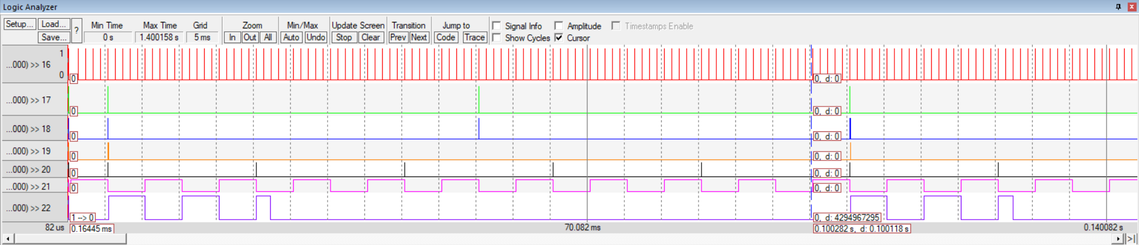

1. Utilization:

%U = (Total Execution Time over one Hyperperiod / Hyperperiod) x 100

= (61.79 / 100) x 100 = 61.79%

1. System Schedulability:
   1. Rate Monotonic:

$$U≤n(2^{\frac{1}{n}}-1)$$

U = 61.79%

N = 6

* 1. Time Demand Analysis:

$$W_{i}= e_{i}+ \sum_{k=1}^{i-1}{\left\lceil \frac{t}{p_{k}}\right\rceil e_{k}}$$

W: Worst Response Time

E: Task Execution Time

T: Time Instance

P: Task Periodicity

I: Task Number

Note: The worst case is when all tasks are being scheduled (High Load) at the start of Hyperperiod, so the worst case is 100 ms

1. Task 1: Button 1 Monitor Task {P: 50, E: 0.02197, D: 50} ms

W3(50) = 0.02197 + 0.02197 + 0.0356 + (6 x 5) + (3 x 0.0268) = 30.15994 < 50

Then, Button 1 Task is schedulable

1. Task 2: Button 2 Monitor Task {P: 50, E: 0.02197, D: 50} ms

W4(50) = (2 x 0.02197) + 0.02197 + 0.0356 + (6 x 5) + (3 x 0.0268) = 30.18191 < 50

Then, Button 2 Task is schedulable

1. Task 3: Periodic Transmitter Task {P: 100, E: 0.0356, D: 100}

W5(100) = (2 x 0.02197) + (2 x 0.02197) + 0.0356 + (10 x 5) + (5 x 0.0268) + (1 x 11.93) = 62.18748 < 100

Then, Periodic Transmitter Task is schedulable

1. Task 4: UART Receiver Task {P: 20, E: 0.0268, D: 20} ms

W2(20) = 0.0268 + (1 x 4.96) = 4.9868 < 20

Then, UART Receiver Task is schedulable

1. Task 5: Load 1 Task {P: 10, E: 4.96, D: 10} ms

W1(10) = 4.96 + 0 = 4.96 < 10

Then, Load 1 Task is schedulable

1. Task 6: Load 2 Task {P: 100, E: 11.93, D: 100} ms

W6(100) = (2 x 0.02197) + (2 x 0.02197) + 0.0356 + (10 x 5) + (5 x 0.0268) + (1 x 11.93) = 62.18748 < 100

Then, Load 2 Task is schedulable

***So, System is schedulable***